
Legal name of corporation: AMERICAN PRODUCTION & INVENTORY CONTROL SOCIETY,
FOX VALLEY CHAPTER, INC.
Note: This organization does business under the name ASCM Fox Valley Forum.

Notice For Meeting Of Members
Of American Production & Inventory Control Society,
Fox Valley Chapter, Inc.
A meeting of the Members of American Production & Inventory Control Society, Fox Valley Chapter, Inc. will be held on April 24, 2024 at Holidays Sports Pub & Grill 3950 N Richmond St. Appleton, WI 54913.
The purpose of the meeting shall be to announce the results of the election of officers for the 2024 – 2025 program year along with the results of votes related to the approval of any changes made to chapter by-laws and articles of incorporation.
Elections for the 2024 – 2025 program year will be conducted through a third party online survey tool. Voting will open on Friday, March 29th and will close on Sunday, April 7th.
If you have any questions, please contact me at (920) 420-1331.
Dated: February 18, 2024
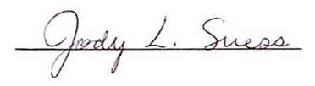
Jody Suess, CPIM, CIRM, CSCP
President, ASCM Fox Valley Forum

